IOT device data pipeline screenshot docs – AWS Services

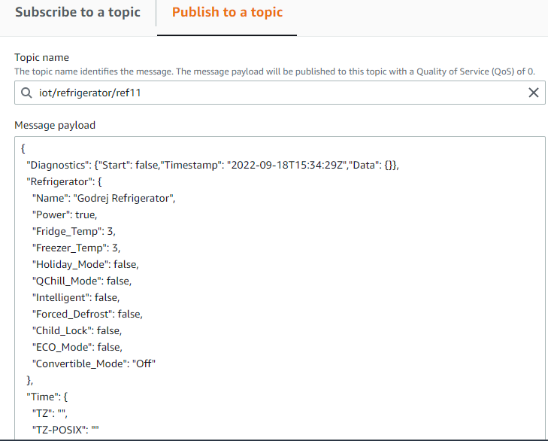

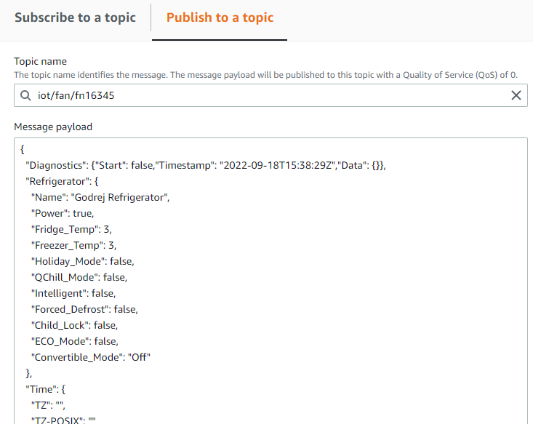

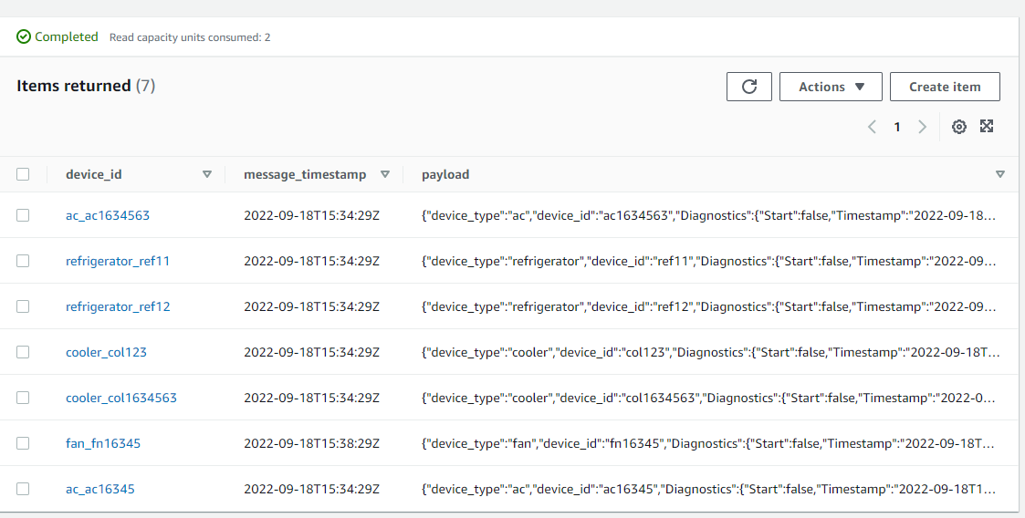

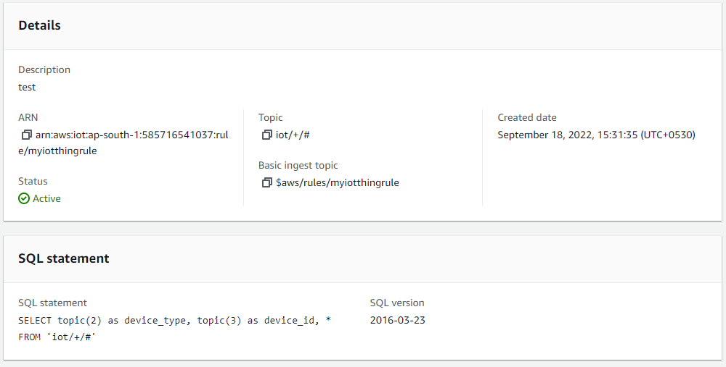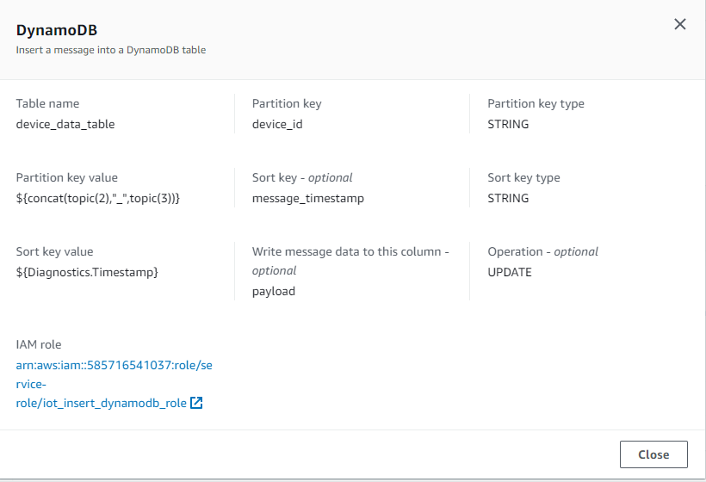

Create Lambda function and role to access dynamodb:

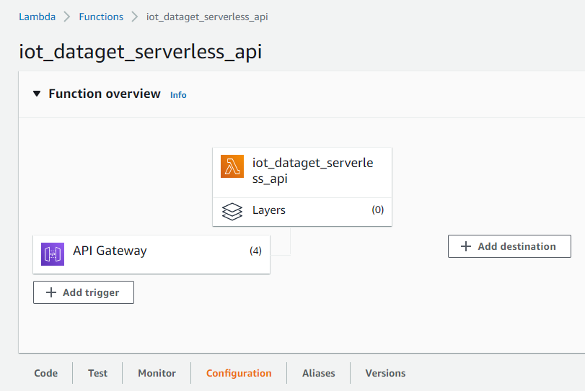

Create api-gateway and add api-gateway to lambda trigger:

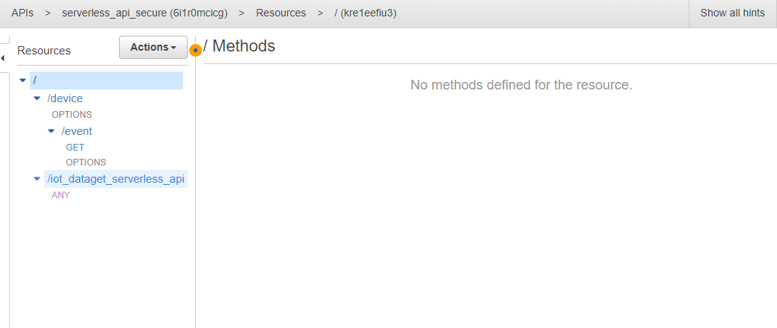

Create Cognito User Pool:

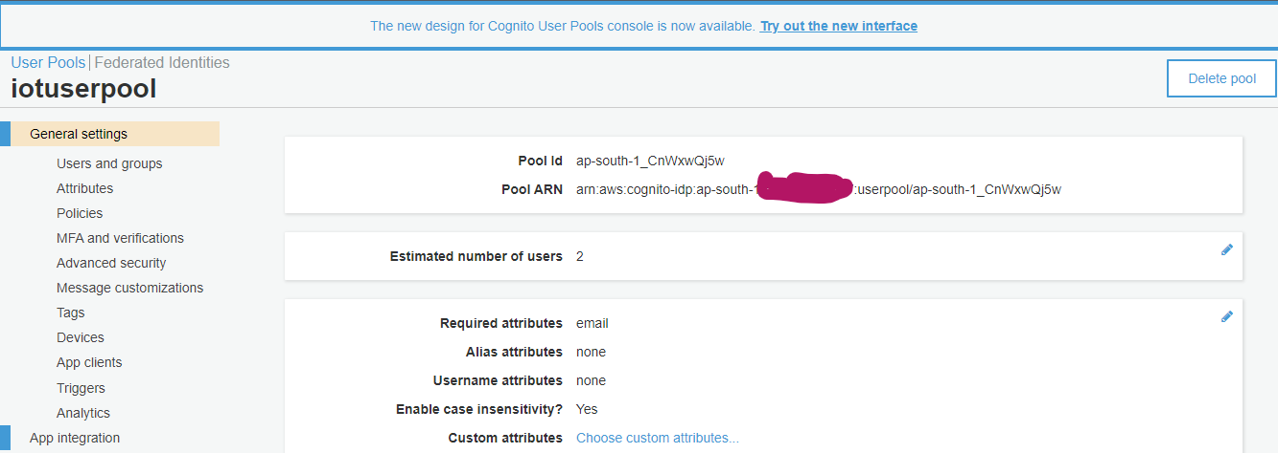

Now, Need to be create app client:

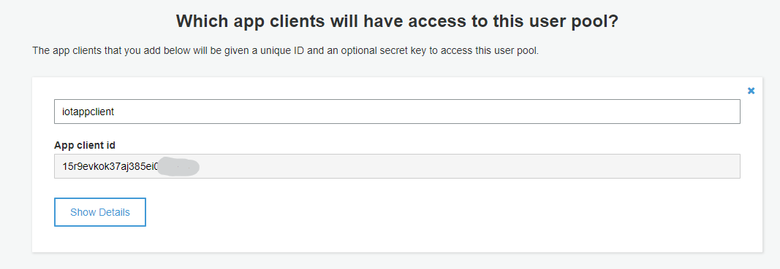

App client settings: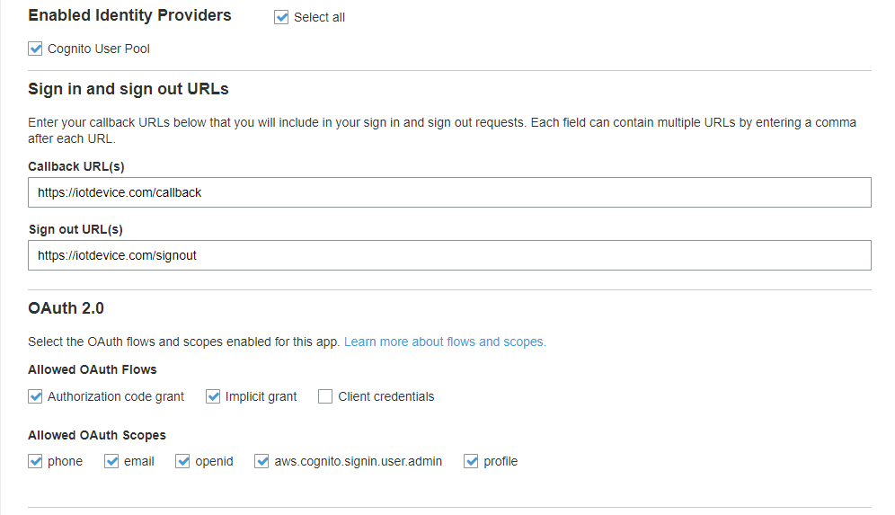

Set the domain name:

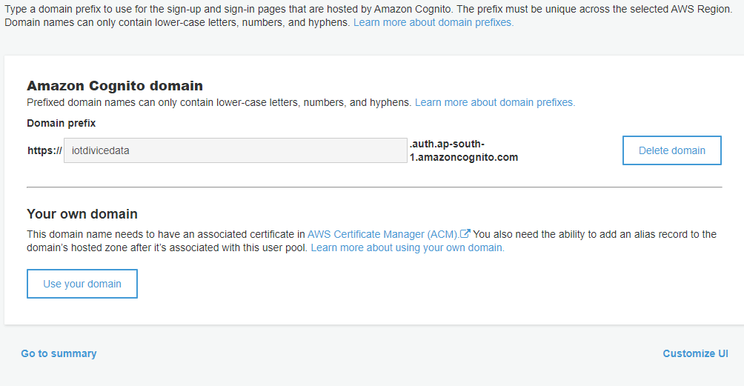

Configure Authorizer in api-gateway:

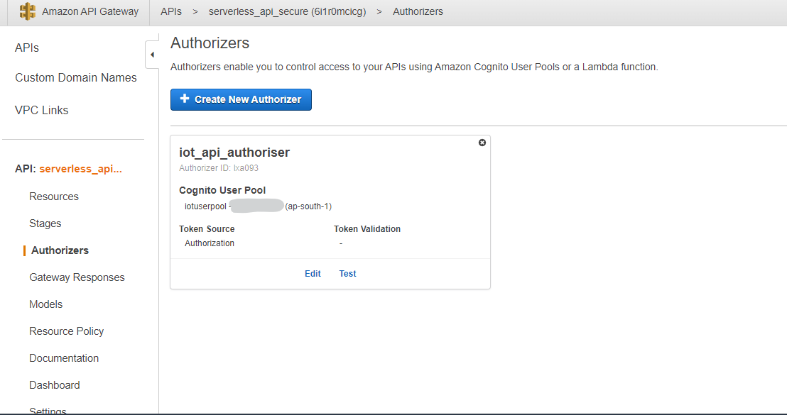

Configure Authorizer with api-gateway resource method ‘GET’:

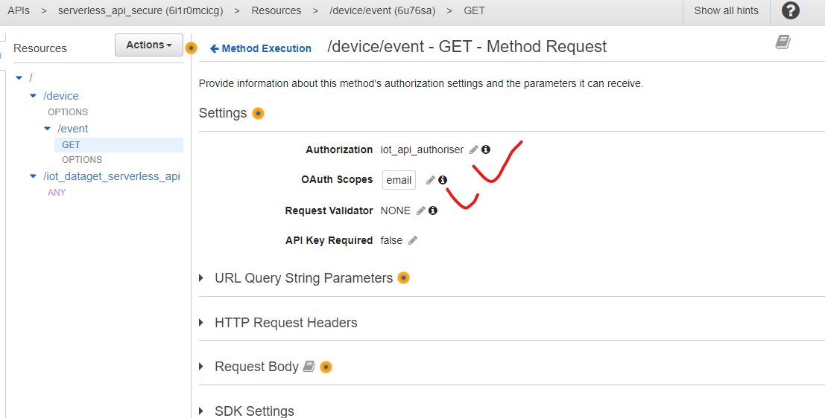

Now go to cognito App client setting there will be “lunch hosted ui” option, just click on this and sign up for user with token:

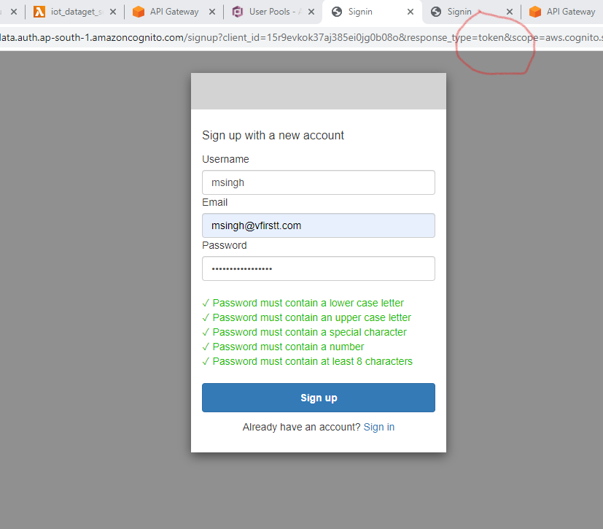

Steps to get token:

Go to cognito>> user pool>> app client settings>> and there will be option below (lunch In the browser it will be showing like URL: https://iotdivicedata.auth.ap-south-1.amazoncognito.com/signup?client_id=15r9evkok37aj385ei0jg0b08o&response_type=code&scope=aws.cognito.signin.user.admin+email+openid+phone+profile&redirect_uri=https://iotdevice.com/callback

So in this URL find the (response_type=code), at the place of code just overwite token (response_type=token)

And then sign up for user

It will give the token id and access whithin this URL for api authorization.

Test the secure api:

Request without access token:

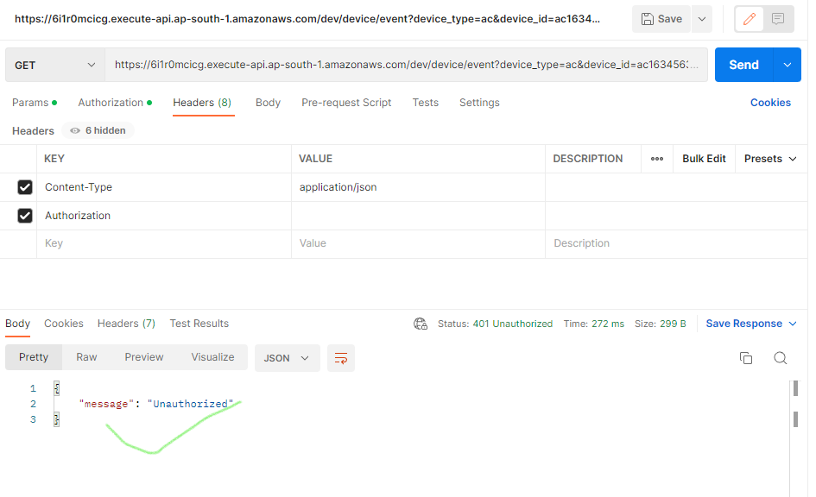

Request with access token:

